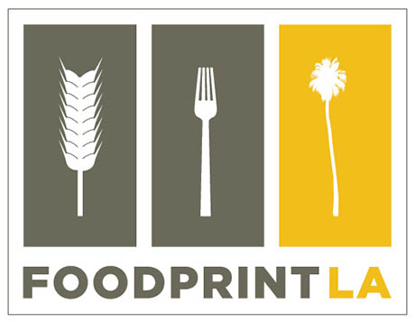

For further information or interview requests,
please contact:

Foodprint Project
Nicola Twilley and Sarah Rich
510.219.1483 or 510.847.5858
foodprintcity@gmail.com
www.foodprintproject.com
Twitter: @foodprintcity
#foodprintLA

FOR IMMEDIATE RELEASE
FOODPRINT LA: December 9, 2012
12:30 – 5.00 p.m.
Los Angeles County Museum of Art (LACMA), Brown Auditorium

Foodprint LA is the fourth in a series of international conversations about food and the city. From a community gardener to a robotic harvesting entrepreneur, this series of four panels will bring together policy makers, historians, food producers, artists, and scientists to ask, When you look at the city through the lens of food, what do you see?

November 26, 2012 – On Sunday, December 9, 2012, from 12:30 to 5:00 p.m., the Foodprint Project will host Foodprint LA, the fourth in its international event series. Co-founded by Sarah Rich and Nicola Twilley in 2010, the Foodprint Project is an ongoing exploration of the ways food and cities give shape to one another.

Presented in the same engaging format that led to lively and idea-filled conversations in New York City, Toronto, and Denver, Rich and Twilley are bringing together a diverse range of LA-based panelists who all work on food-related issues, from very different points of view. The event’s goal is to generate fresh insights into the hidden forces that have shaped the Angeleno foodscape, and to speculate as to how we might reshape the city’s relationship with food in the future.

Four back-to-back panels will bring together an artist (Jessica Rath, whose latest sculptures explore apple breeding) with a paleofuturist (Matt Novak, whose Smithsonian-hosted blog investigates the futures we imagined in the past), a food critic (the legendary Jonathan Gold) with a cell-phone food mapper (Benjamin Stokes, a civic media scholar specializing in participatory mapping), and many more, including Paula Daniels, the Mayor’s Senior Adviser on Food Policy and Special Water Projects, Christina Agapakis, a synthetic biologist best known for her creation of “human cheese,” Hadley Arnold, co-director of the Arid Lands Institute, and Mary Lee, Deputy Director of the Center for Health Equity and Place at PolicyLink.

Guest moderator Geoff Manaugh (author of the speculative architecture blog, BLDGBLOG) will kick off the day with Zoning Diet, a conversation about the ways in which infrastructure, policy, and economics shape LA’s food systems. Foodprint Project co-founder and Edible Geography author Nicola Twilley will lead the second panel, Culinary Cartography, an exploration of what can we learn when we map LA using food as the metric.

Following on from that, Foodprint Project co-founder and author of Urban Farms (Abrams, 2012) Sarah Rich will dive into Edible Archaeology, a look at LA’s food history in the context of the present; and guest moderator Alexis Madrigal, Senior Editor at The Atlantic, will bring the day to a close with Feast, Famine, and Other Scenarios — a chance to speculate on the opportunities and challenges of LA’s possible food futures.

“Food events and conferences are ten a penny these days,” says Nicola Twilley, Foodprint LA’s co-organizer, “but we think we’re offering something truly different: a behind-the-scenes glimpse at the often invisible forces — economic, policy-driven, historical, demographic, infrastructural, and technological — that structure the way the city feeds itself today.”

According to co-organizer Sarah Rich, “Los Angeles is a particularly interesting place for a cross-disciplinary discussion of the past, present, and future of food and the city.” As recently as the 1950s, Los Angeles county was the largest agricultural producer in the nation; in 2009, one in ten Angelenos received some form of food assistance. Los Angeles’ relationship with its agricultural hinterlands plays a pivotal role in California’s endless water wars and the city’s sprawling geography and ethnic diversity mean that it has pioneered trends that shape the national foodscape, from drive-through dining and taco trucks to fortune cookies and fusion food.

In other words, if we can begin to re-imagine the relationship between food and the city here in Los Angeles, then the ideas we generate toward a more sustainable, resilient, equitable, and healthy city can become models for change on a global scale.

Foodprint LA is open to the public (with seating for just over 100); admission is free with no RSVP required. It is curated by Sarah Rich and Nicola Twilley, and will take place on Sunday, December 9, 2012, from 12:30 to 5:00 pm. The program is being hosted by LACMA (5905 Wilshire Boulevard, Los Angeles, CA 90036) and is made possible by a successful Kickstarter campaign. For press requests, reserved seating, and more information, including panelist bios, media clips, and footage from previous events, contact foodprintcity@gmail.com or visit the event website at www.foodprintproject.com. #

